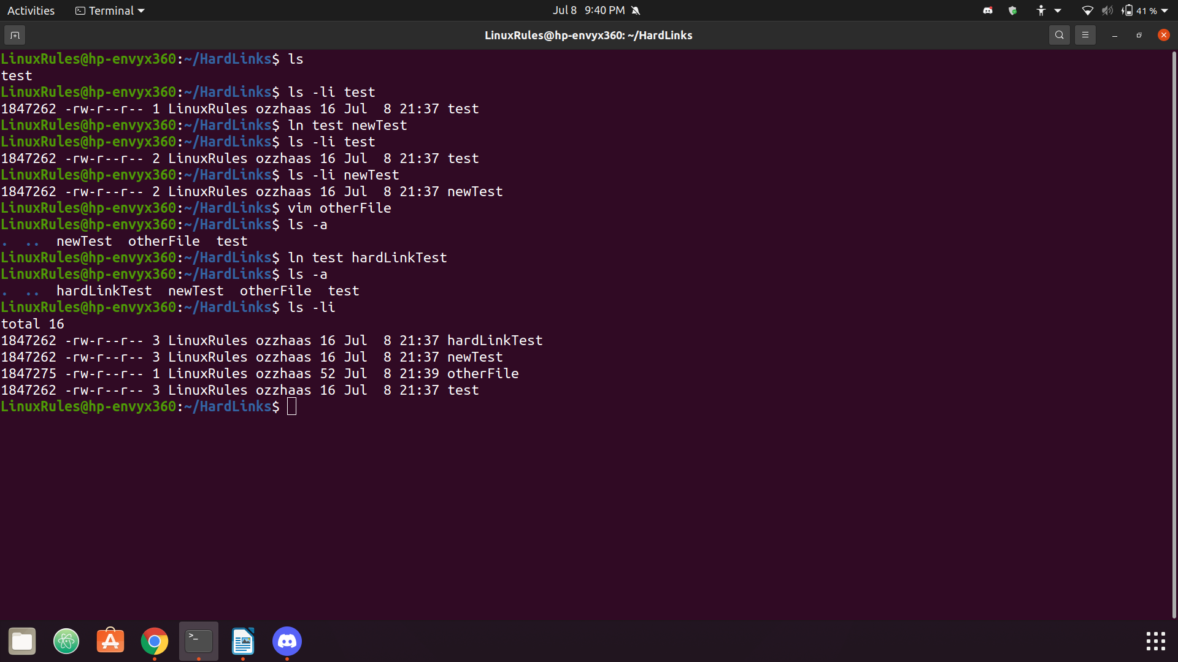
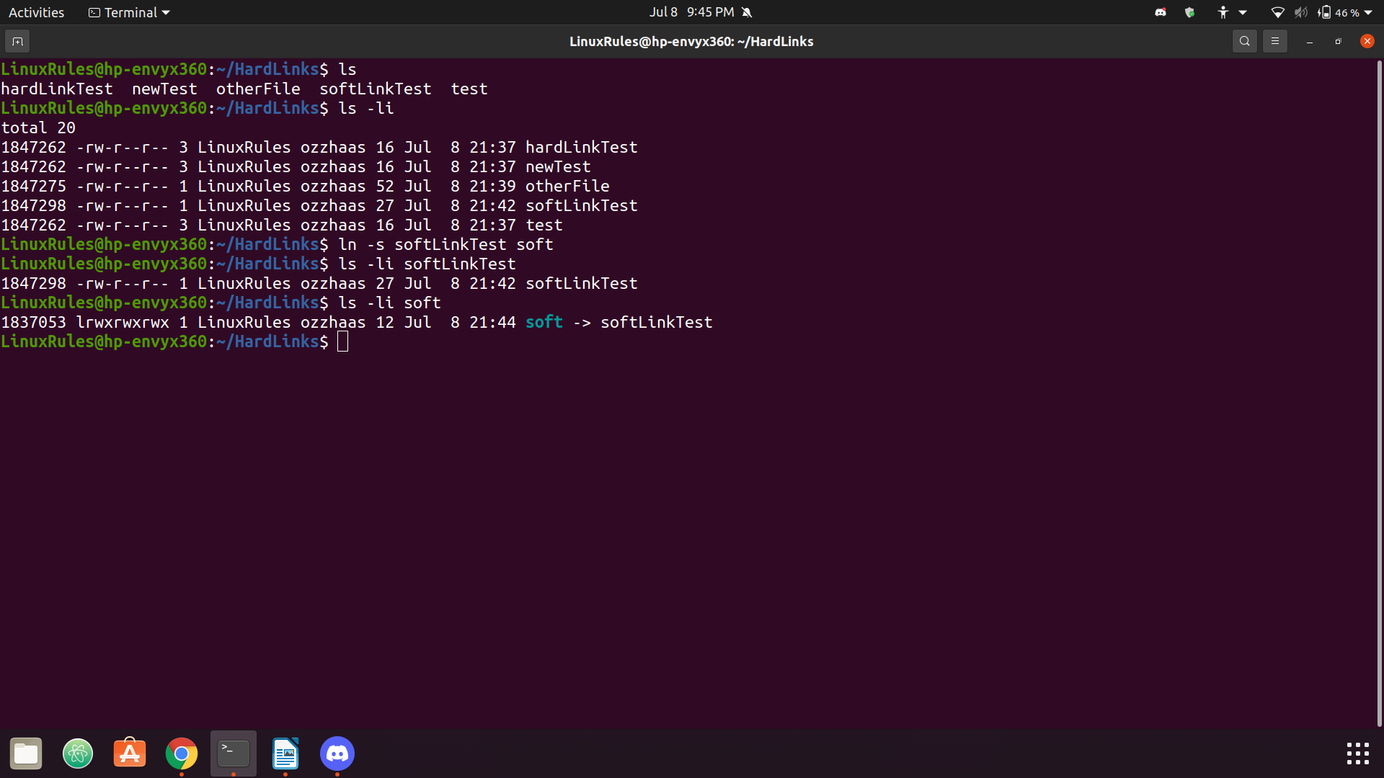
CPSC 4240/6240 Discovery 2 50 points Name: ___Kellen Haas
Instructions:
This homework is done individually, not in groups. You are allowed to use search engines, textbook/s, lecture notes, and any other sources you wish. But you are not allowed to copy-paste from Internet, or help others with their work, either by giving them hints or solutions.
You will take a number of screenshots. All screenshots should be clearly legible and illustrate without a doubt what you are doing. You can open them in an image editor of your choice and trim off the parts you do not need, just to make images smaller. Insert them when answering the question, do not submit them separately as image files. Since this is an editable word document, you can make space between the questions and type your answers and insert screenshots here. Please do not type in red, any other color is fine. I read everything you write, so if you just type in black, I will not miss your answer 😊
Grading and Points
Every question indicates how many points it is worth. 4000-level and 6000-level are graded differently, with points indicated as (x/y), where x is 4240 and y is 6240.
Exercises
- In this exercise you will experiment with hard links. Every time you create a hard link to a file, its reference count increases. But a newly created empty directory has a reference count of 2. Please explain why this is the case. Also, explain why a directory needs a . and a .. (8/7)
All directories have a special entry “.” and “..” to represent the directory itself and its parent directory respectively. The root directory doesn’t have a parent directory, the path “/..” is the same as “/.” and “/”. It is not recommended to create hard links between directories as this can cause filesystem loops and directories that don’t have a single, unambiguous parent. Soft links are recommended for linking directories.
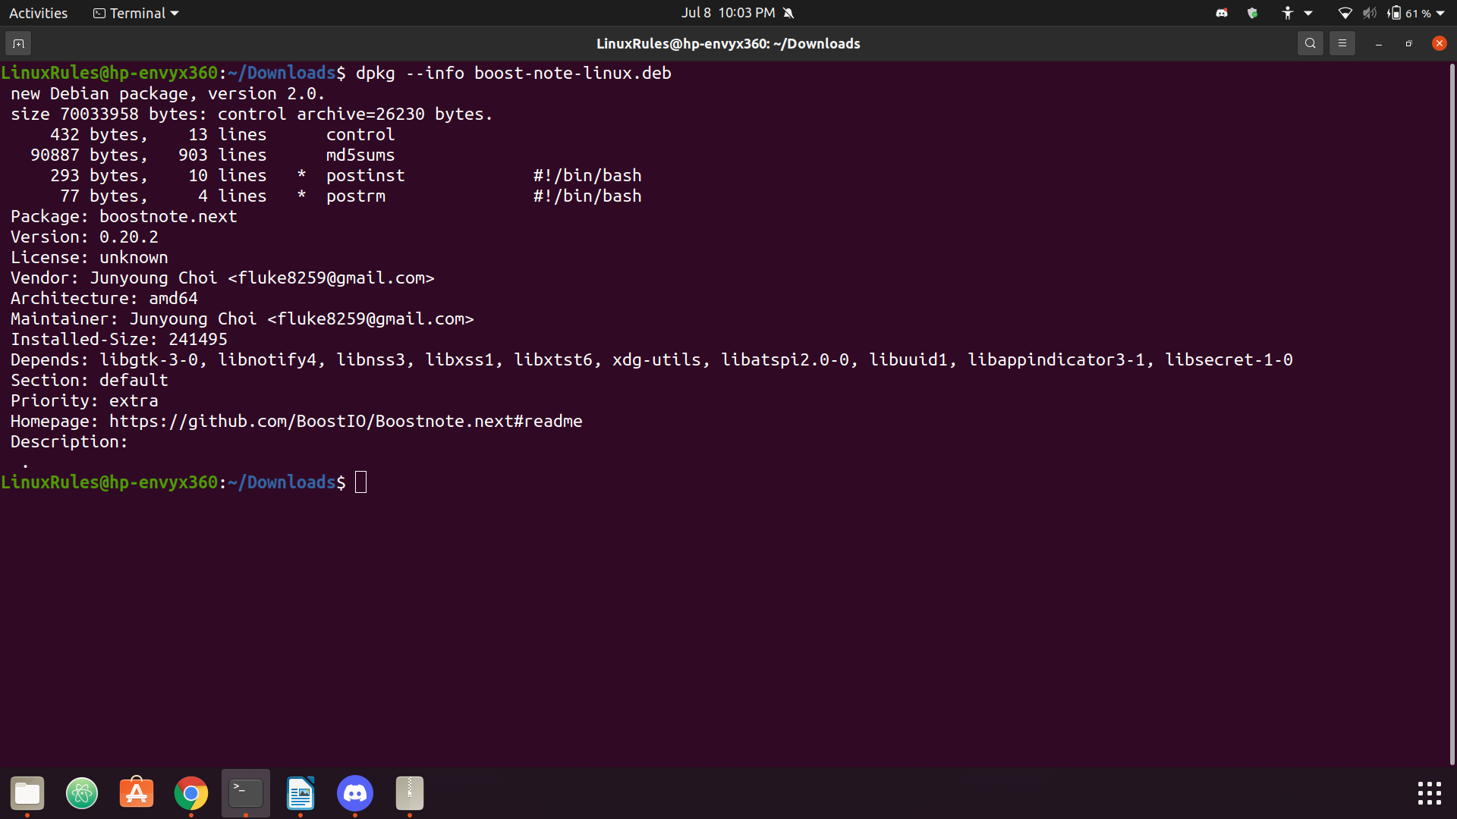
- Search online and download some .deb file (other than Google Chrome). You do not need to install that program, just unzip the archive and inspect the package itself. There are two directories and a file in the folder. Unzip each directory and inspect each file in each folder (similar to what we did in class). What files are there, and what is the purpose of each file? You do not need to copy/paste the contents, but you need to explain what that file's function is. (10/9)
The first file that is with the two zipped directories inside of the deb package is a “debian- binary” file.
The two directories that are listed can be untar’d in order to see the files inside. The control directory is a compressed file with md5sums inside and the directory for building the package. It also contains the files “postinst” and “postrm”. The data directory is also a compressed file, but it contains all the files that the installer will install on your system. The contents of the md5sums file are of the types:
.gz | .txt | .html | .next
.pak | .dat | .so | .bin
.next.desktop | .js | .css | .ttf
.woff | .woff2 | .svg | .png
.xml | .ico | .icns | .jpg
.json | .js.map
Contents of the control file can be viewed in the screenshot below.

The following screenshots are examples of content inside of the data tar’d file:
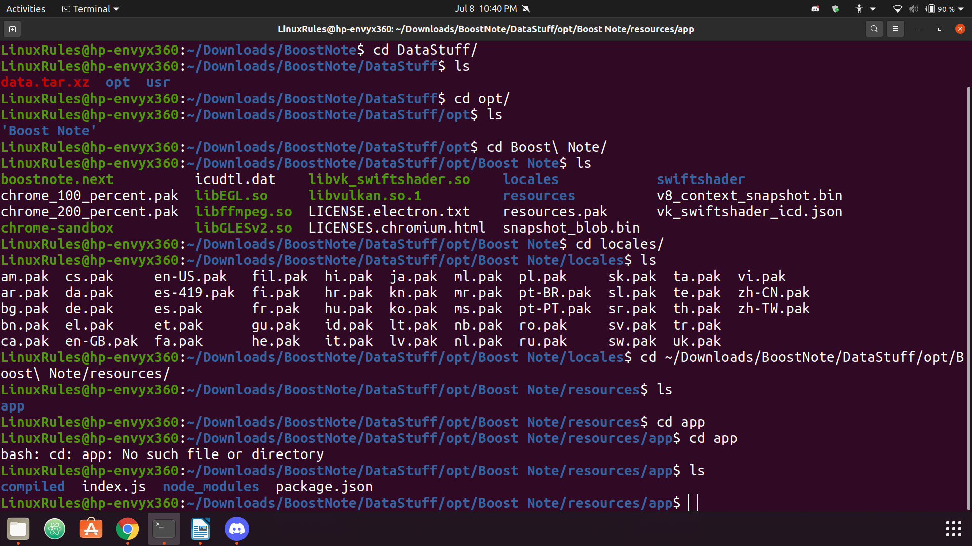
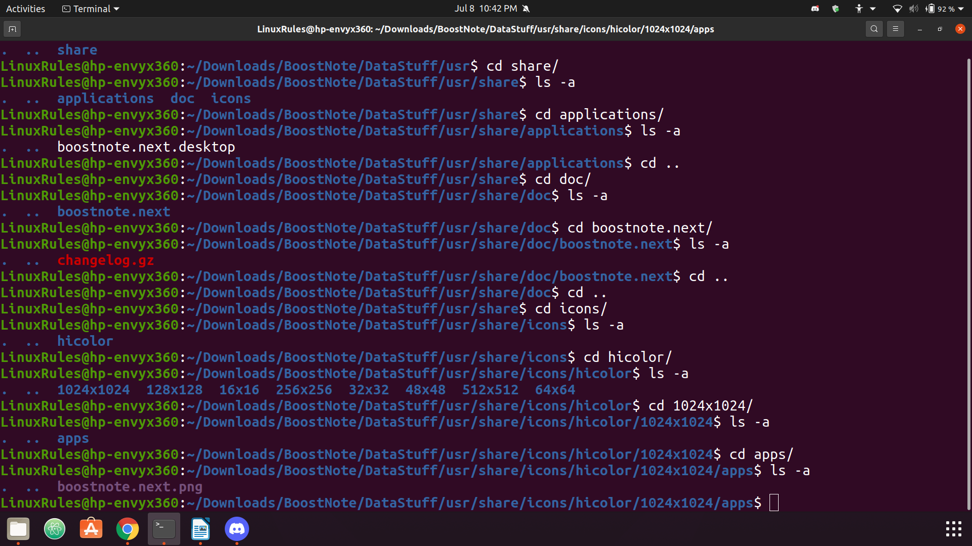

- Explore /dev directory. It contains files associated with all physical, virtual, and pseudo devices. Notice that there is a number of loop devices and tty devices.
a. Explain what they are and why are there so many of them?
Device files are characterized by two specific numbers, the major and minor device numbers. The major device number tells the kernel which driver the file specifies and the minor tells the driver which physical unit to address. tty has the major device number 4 indicating it is a serial driver. The first virtual console on the system is tty0 (so it’s minor number is 0). The serial driver ports are typically used to connect an external modem to the system.
The kernel will usually have a “loop” filesystem as well that allows users to mount individual files like they are distinct devices.
There are quite a few loop and tty files in the /dev directory because the devices that they represent can be physical, virtual, or pseudo devices.

b. Also, explain the difference between tty and pts devices. (8/7)
The difference between tty and pts devices is the way in which they are connected to the computer or system. tty ports are either directly connected to the computer or are a serial connection to a device. Alternatively, pts connections are via SSH or telnet.

- Explore journald.conf file. What are the 4 Storage options and what does each option mean? Set the limit of how much hard drive space logs can use (4GB), and how much space should be left for other users to use (50GB). Set maximum file size to 3GB. Show a screenshot of your configuration file where you set these values. (8/7)
- Volatile – the journal log data will be stored in memory (below the /run/log/journal directory)
- Persistent – the journal log data will be stored ideally on a disk (below the /var/log/journal directory, or will use /run/log/journal as a backup during early boot or if the disk is not writable)
- Auto – Similar to persistent but the directory /var/log/journal is not created if needed, so that the existence of that location controls where the log data will go.
- None – Disables all storage and causes all log data that the system receives to be dropped.

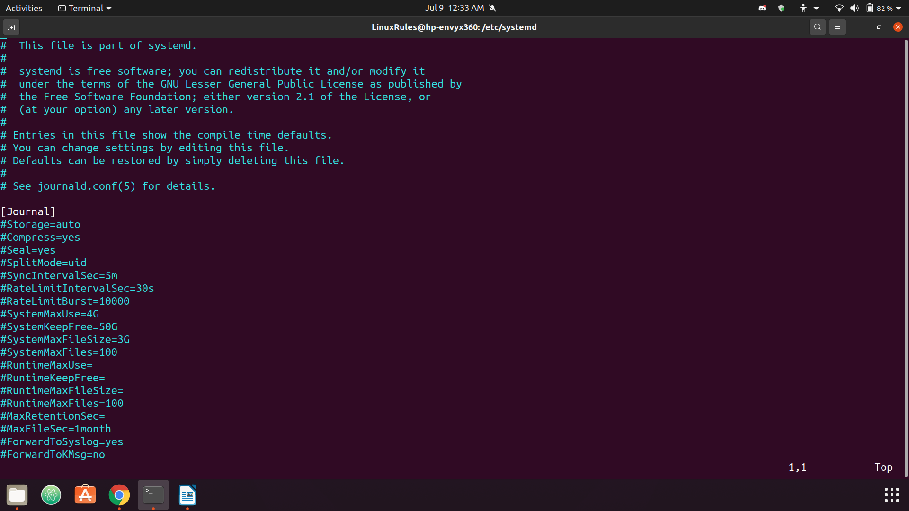
- Experiment with log rotation feature. Explain what you have tried, what you learned, and show a screenshot or two to illustrate your point. (8/7)

- Linux filesystem contains many different file types, such as regular files, directories, and links that are indicated by -, d, or an l in the long file listing. There are two file types that you probably have not seen so far, they are called pipes (or named pipes) and sockets and contain letters p and s in front of the permissions bits in long listing format. Please do some research and explain what those pipes and sockets are, and what their function in the filesystem is. Then search directories and find two examples of each. Please attach screenshots. (8/7)

Graduate Students:
Linux kernel is open source. In this exercise you will search and download the latest kernel source code. What is the latest kernel version? Please provide the link where you have found the source code. What is the size of the file you have downloaded? Open the archive and inspect the code. What is the structure/layout of the kernel source code, what do directories contain? Open some files in an editor and try to figure out what the code does. Please describe your observations. Include some screenshots to illustrate your narrative. (0/6)
Undergraduate students can do this exercise for 3 extra credit points.

